Air Frame Analysis

MAE 157A: Fluid Mechanics and Aerodynamics Laboratory

**Prescott Rynewicz, UCLA MAE Undergraduate Student**

Professor

R. Mitchell Spearrin, Ph.D.



Table of Contents

Introduction 3

List of Tables 4

List of Figures 5

Individual Tasks 7

Results & Discussion 7

Stress, Displacement and Factor of Safety Comparison 12

Team Tasks 15

Results & Discussion 15

Summary and Conclusions 18

Statements of Participation 20

Individual Tasks 20

Team Tasks 20

Team Members Rated 20

Appendices 21

# **Introduction**

This lab focuses on the fundamental process of engineering design. The key elements in this process are the background theoretical knowledge obtained in the classroom, which is transferred directly into numerical modeling techniques to gain a better understanding of the real world complicated systems. These numerical models are then compared to experimental results found by running real world versions of the simulations. The specific components being constructed in this lab were aluminum and carbon fiber cylinders. Three different cylinders experiencing a compressive load were constructed in SolidWorks and studied using finite element analysis to observe the effects of a compressive load on the cylinders. Physical parts were then constructed based off these models and were tested to failure under a compressive load press. The numerical simulations are then compared to the experimental results, and all of this data will be used to guide the design and development of SpaceY’s model rocket for the rest of the quarter.

# **List of Tables**

Table 1: SolidWorks Simulation Results for 3 Cylinder Loading Cases................................11

Table 2: Failure Cases for 20kN Loading Simulations..........................................................12

Table 3: Strength to Weight Ratios for Simulated Loads.....................................................13

Table 4: Yield and Buckling Failure Results for Simulated Loads.........................................13

Table 5: Strength to Weight Ratios for Experimental Data.................................................18

# **List of Figures**

Figure 1: Case I Stress with a Deformation Scale of 48.2262 7

Figure 2: Case I Displacement with a Deformation Scale of 48.2262 8

Figure 3: Case I Factor of Safety Distribution with a Minimum FOS of 0.73 8

Figure 4: Case II Stress with a Deformation Scale of 94.8427 9

Figure 5: Case II Displacement with a Deformation Scale of 94.8427 9

Figure 6: Case II Factor of Safety Distribution with a Minimum FOS of 1.5 10

Figure 7: Case III Stress with a Deformation Scale of 73.2226 10

Figure 8: Case III Displacement with a Deformation Scale of 73.2226 11

Figure 9: Case III Factor of Safety Distribution with a Minimum FOS of 4.3 11

Figure 10: Case 3 Stress Plot: Incorrect Thickness…………………………………….…………………………25

Figure 11: Case 3 Factor of Safety: Incorrect Thickness……………………….…………………………25

Figure 12: Case 3 Displacement Plot: Incorrect Thickness………………………………………………26

# **Individual Tasks**

## Results & Discussion

*Note: The ComSol simulations that I completed used a thickness that was incorrect by a factor of 0.5. In order to save multiple hours waiting for Seaslab computers to rerun the simulations, the images used in this report are sample images obtained from a class mate. A section comparing the effect of thickness is included in the report, along with my own incorrect simulations in the appendix.*

1. **Show and comparatively discuss your plots for Stress, Displacement, and Factor of Safety for all 3 studies. How do the results scale or compare with material thickness and material type? Be quantitative.**

Case I

*Conditions – Aluminum 3003-H14, 0.035” wall thickness*

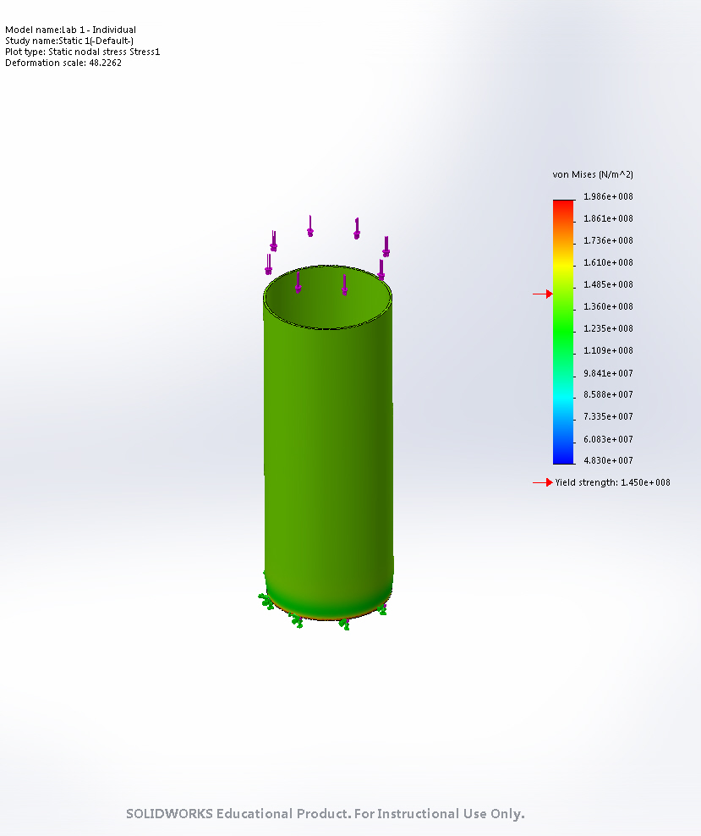

Figure 1: Case I Stress with a Deformation Scale of 48.2262

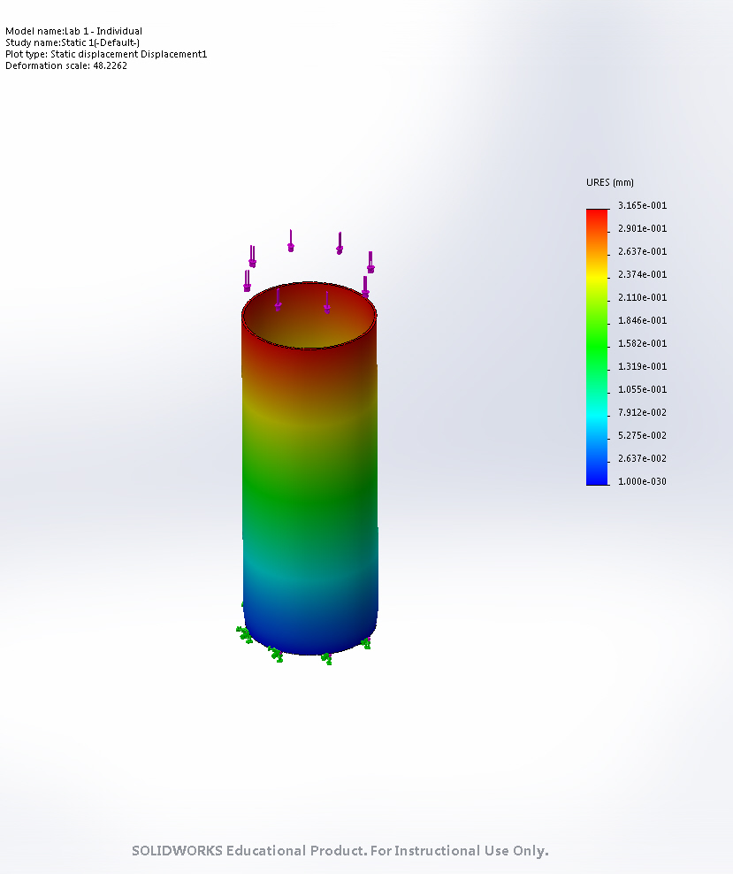

Figure 2: Case I Displacement with a Deformation Scale of 48.2262

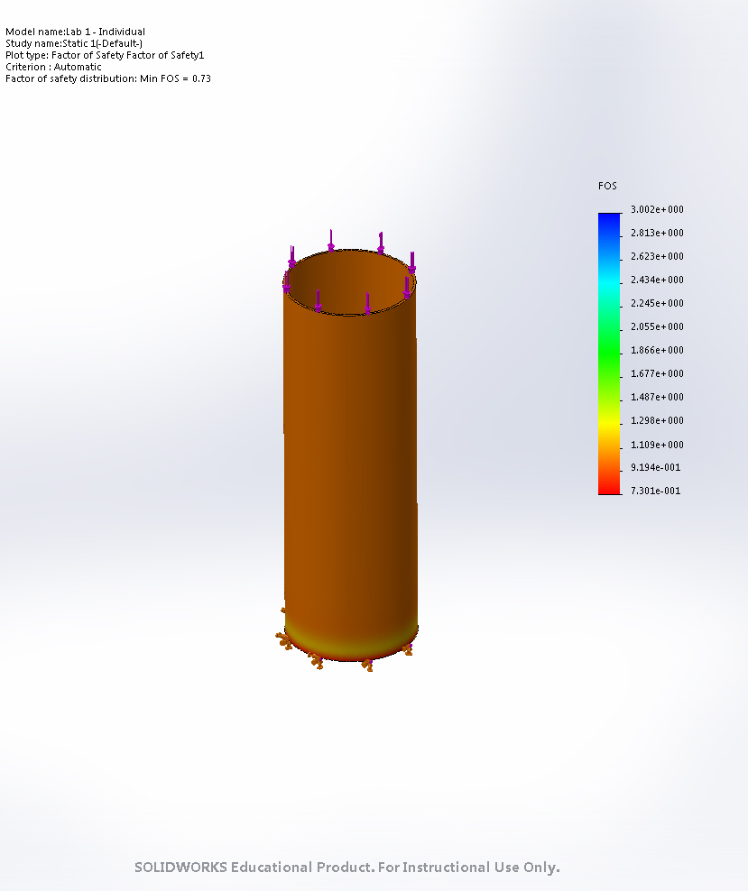

Figure 3: Case I Factor of Safety Distribution with a Minimum FOS of 0.73

Case II

*Conditions – Aluminum 3003-H14, 0.07” wall thickness*

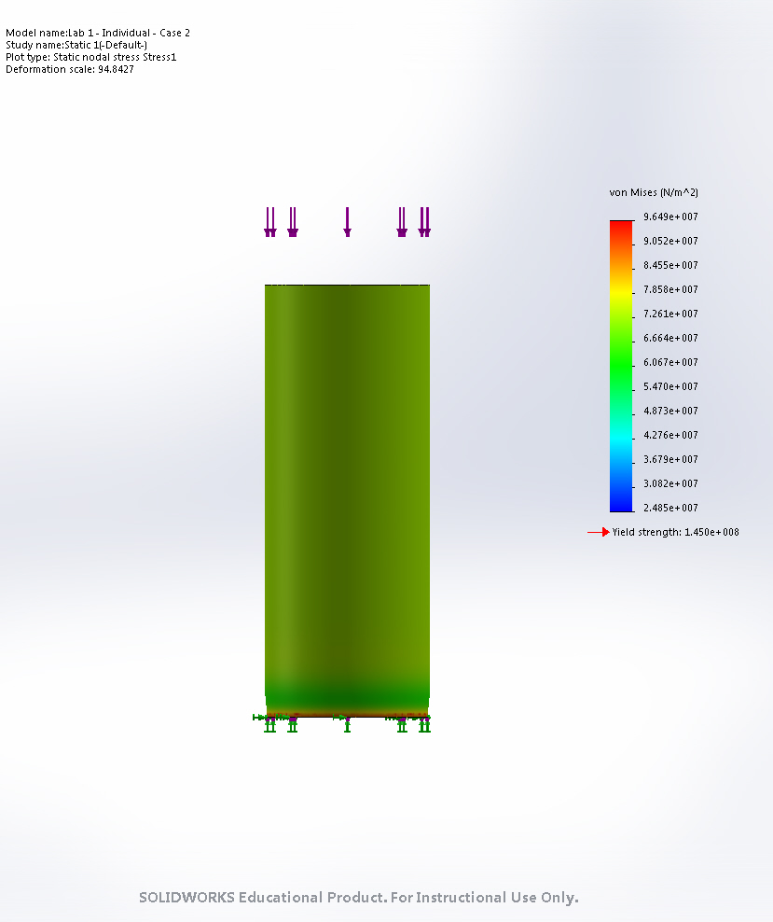

Figure 4: Case II Stress with a Deformation Scale of 94.8427

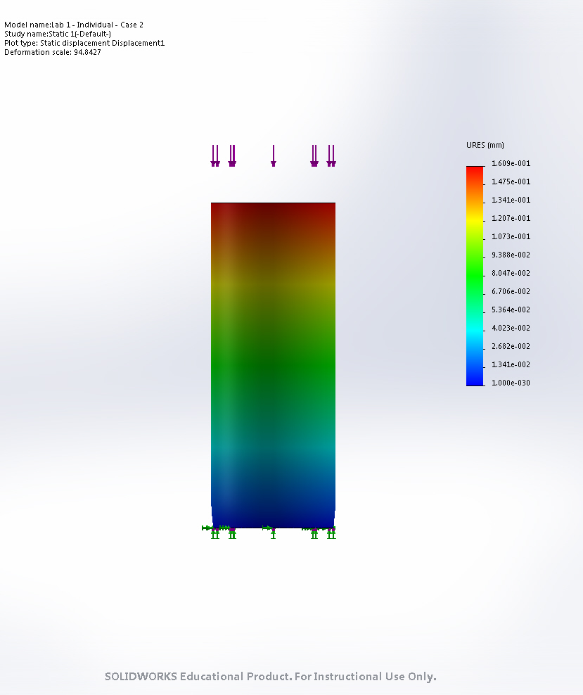

Figure 5: Case II Displacement with a Deformation Scale of 94.842

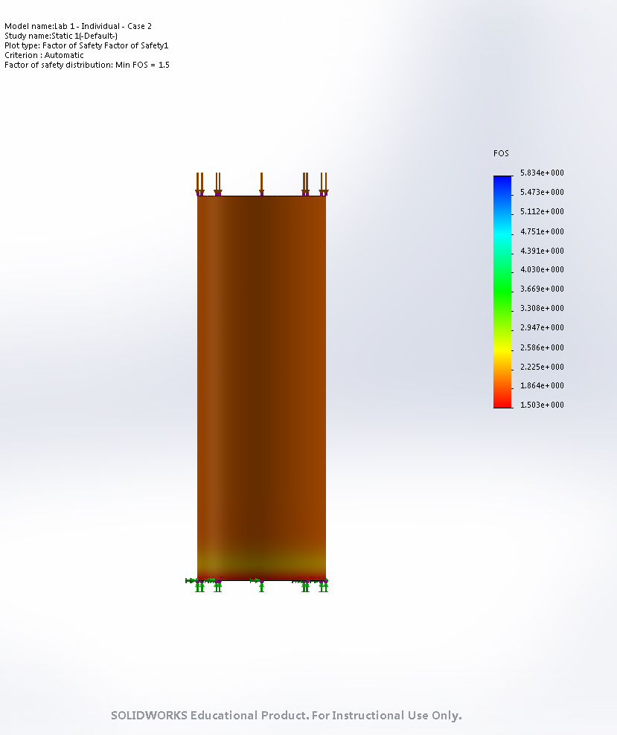  
Figure 6: Case II Factor of Safety Distribution with a Minimum FOS of 1.5

Case III

*Conditions – Ti-6Al-4V, 0.035” wall thickness*

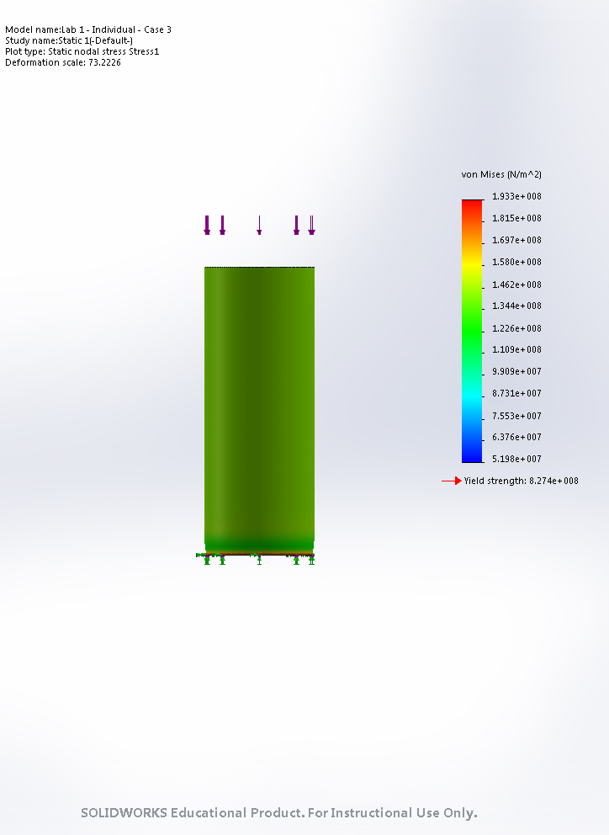

Figure 7: Case III Stress with a Deformation Scale of 73.222

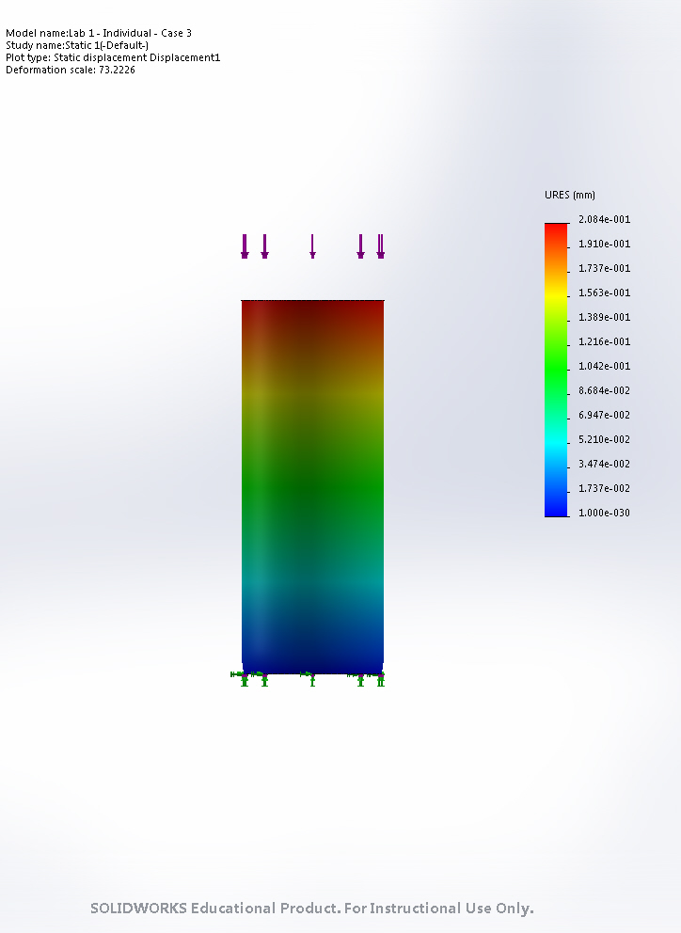

Figure 8: Case III Displacement with a Deformation Scale of 73.2226

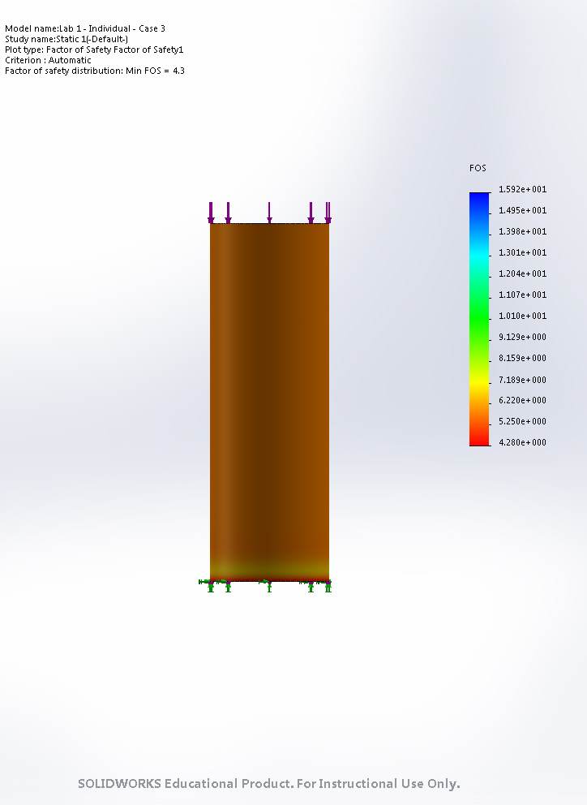

Figure 9: Case III Factor of Safety Distribution with a Minimum FOS of 4.3

A table summarizing important values from the Stress, Displacement, and Factor of Safety plots is shown below.

|  |  |  |  |
| --- | --- | --- | --- |
|  | Case I | Case II | Case III |
| Material | Aluminum 3003-H14 | Aluminum 3003-H14 | Ti-6Al-4V |
| Wall Thickness (in) | 0.035 | 0.070 | 0.035 |
| Minimum Stress Distribution (N/m2) | 4.830 x 107 | 2.485 x 107 | 5.198 x 107 |
| Maximum Stress Distribution (N/m2) | 1.986 x 108 | 9.649 x 107 | 1.933 x 108 |
| Yield Strength (N/m2) | 1.450 x 108 | 1.450 x 108 | 8.274 x 108 |
| Minimum Displacement (mm) | 1.000 x 10-30 | 1.000 x 10-30 | 1.000 x 10-30 |
| Maximum Displacement (mm) | 3.165 x 10-1 | 1.609 x 10-1 | 2.084 x 10-1 |
| Minimum Factor of Safety | 0.73 | 1.50 | 4.28 |
| Maximum Factor of Safety | 3.00 | 5.83 | 15.92 |

Table 1: SolidWorks Simulation Results for 3 Cylinder Loading Cases.

# Stress, Displacement and Factor of Safety Comparison

The primary comparison that can be made in this section is between the two variations of aluminum. One with a thickness of .035 inches, and the other with a thickness of 0.07 inches. The primary relation between all values for these two casings is that all values differ by very close to a factor of 2. The Maximum and Minimum stresses between the 2 casings are both differ by factor of 2, along with the Maximum displacement, minimum and maximum factor of safety. For the Titanium Casing, there is not any direct correlation of comparison to the aluminum outside of the known differences in material properties. Titanium is known to be a stronger material compared to aluminum, which can be seen in the test results. Titanium has a yield strength that is 5.65 times greater than aluminum, which presents a 1.65 times greater critical buckling load, a 5.70 times greater critical yield load, and 3.6 times greater strength to weight ratio than aluminum.

Overall, when designing an electromechanical system which will experience an extreme set of loading conditions – applied force, stress, and displacement are all critical components that need to be considered during the design process, along with a reasonable factor of safety for all of these physical constraints.

1. Which cases will fail under a 20kN load? Explain why the other cases do not fail.

Under a 20kN load, the cases that will fail will be only case 1. This is determined through the simulation results. The first aluminum case shows that under a 20kN load, the minimum factor of safety found throughout the component is 0.73, which tells us the applied load is greater than the yield strength of the material, and will cause failure. The other two cases have minimum factors of safety that are greater than 1, and are also reasonably high that under the correct design constraints, could be used in a real world physical system. The total results are tabulated below.

|  |  |  |  |
| --- | --- | --- | --- |
|  | Case I | Case II | Case III |
| Failure at 20kN | True | False | False |

Table 2: Failure cases for 20kN Compressive load.

1. Tabulate the strength to weight ratios of the Aluminum 3003-H14 and Ti-6Al-4V studies

In order to calculate the strength to weight ratios, we will use the equation below.

$$STW=\frac{\frac{yield_{strength}}{Area}}{ρ}=\frac{\frac{yield_{strength}}{Area}}{\frac{mass}{Area*height}}=\frac{yield_{strength}*height}{mass}$$

With this equation, the data collected from the SolidWorks Simulations, and the material properties of Aluminum 3003-H14 and Ti-^Al-4V we are able to calculate the Strength to weight Ratios, which are presented below.

|  |  |  |  |
| --- | --- | --- | --- |
|  | Case I | Case II | Case III |
| Density [kg/m^3] | 2800 | 2800 | 4430 |
| Strength to Weight Ratios (kN*m/kg) | 51.78 | 51.78 | 186.68 |

Table 3: Strength to Weight Ratios for Simulated Loads.

1. Now calculate the force required to buckle the same tube with a length of 6”. Assume both ends are fixed (𝒏 = 𝟒.). Also, calculate the length of the cylinder which was cause buckling failure.

To calculate the critical yield force, we use the equation…

$$σ_{yield}=\frac{F_{cr_{yield}}}{A}$$

$$F_{cr_{yield}}=σ_{yield}*A$$

To calculate the length that will cause buckling failure first, we will use the equation…

$$F_{cr_{buckling}}=\frac{nπ^{2}EI}{L^{2}}=F_{cr_{yield}}=σ_{yield}A$$

$$L=\sqrt{\frac{nπ^{2}EI}{σ_{yield}A }}$$

due to the Force for critical buckling needing to be equal than or greater than the force required for yielding.

The total results are displayed in the table below.

|  |  |  |  |
| --- | --- | --- | --- |
|  | Case I | Case II | Case III |
| Critical Yield Force [kN] | 20.21 | 39.70 | 115.28 |
| Critical Buckling Force [kN] | 5.09 | 9.66 | 8.40 |
| Length for Buckling Failure (m) | 2.42 | 2.37 | 1.30 |

Table 4: Yield and Buckling Failure Simulation results.

# **Team Tasks**

## Methods and Manufacturing

This section will very briefly present and describe some photographs of the procedures taken for manufacturing and testing within this lab.



Image 1: Pre Heating Carbon Fiber Preparation



Image 2: Wrapping Carbon Fiber in Vacuum Bagging



Image 3: Post Sealed and Heated Carbon Fiber Construction



Image 4: Removal of Exterior components from Carbon Fiber Tube.



Image 5: Load Testing Cardboard Rolls



Image 6: Load Testing Single Layer Carbon Fiber Tube.

Overall, our team of 5 constructed one single layer carbon fiber tube which was then used in a load press to determine the failure conditions for the single layer tube. This data for the single layer tube was compared against a toilet paper cardboard cylinder, an aluminum cylinder and a 6 layer carbon fiber composite tube as constructed by the TA’s.

# Results & Discussion

1. **At what load does the carbon fiber airframe fail? Assume the maximum static thrust of your rocket motor is 110 N. If the air frame bears this load, what factor of safety does this give you for your airframe in static loading?**

The carbon fiber tube failed at 1171.55N of compressive load. If a static load of 110 N is applied during launch, that means a factor we have a factor of safety equal to

$$FOS=\frac{Yield Force}{Applied Force} =\frac{1171.55}{110}=10.65$$

This is well within the acceptable values of factor of safety for this type of vehicle, and would be appropriate to design a vehicle with this amount of stress factor of safety.

1. **For isotropic materials, strength to weight ratios are often just a material property; however, this differs for composite materials. Why? Using your experimental data, calculate and discuss the strength to weight ratios for the following samples: aluminum, single-layer carbon fiber, multi-layer carbon fiber.**

Strength to weight ratio is not a material property for composites due to manufacturing techniques that play important roles in the failure properties for the material. Carbon fiber composites can be manufactured in many different ways, which will affect the failure results, even if the resulting parts have the same weight and dimensions.

The table below shows the results for the strength to weight ratios of the aluminum, single layer carbon fiber, multi layer carbon fiber, and cardboard toilet paper roll.

|  |  |  |  |  |
| --- | --- | --- | --- | --- |
|  | 6-Layer Carbon Fiber | Al 3003-H14 | Rolled Paper | 1-Layer Carbon Fiber |
| Mass [kg] | 0.0278 | 0.044 | 0.0056 | 0.0053 |
| Wall Thickness [m] | 0.001346203 | 0.000889002 | 0.000762002 | 0.00038 |
| OD [m] | 0.053492507 | 0.050800102 | 0.043942088 | 0.05173 |
| Height [m] | 0.087312675 | 0.118110236 | 0.139700279 | 0.09999 |
| Area [m^2] | 0.000220538 | 0.000139396 | 0.000103369 | 6.13019E-05 |
| density [kg/m^3] | 1443.722224 | 2672.486353 | 387.7943998 | 864.6600307 |
| Max Compressive Load [N] | 33,472 | 20,217 | 155 | 1171 |
| STW (kN*m/kg) | 105.1269728 | 54.26896922 | 3.866704162 | 22.09213019 |

Table 5: Strength to Weight Ratios for Experimental Data.

1. **How does this compare to your simulated results of Aluminum 3003-H14 and Ti-6Al-4V?**

These values align very well with the simulated values given by the SolidWorks Finite Element Analysis. The strength to weight ratio for the simulated aluminum cylinder of equal dimensions was found to be $stw=51.78 [kN*\frac{m}{kg}]$. The Experimentally calculated strength to weight ratio was found to be $stw=54.26 [kN*\frac{m}{kg}]$. If we calculate the error between these two values we get…

$$Error=\frac{\left|stw_{theoretical}-stw_{experimental}\right|}{stw_{theoretical}}*100 = 4.78\%$$

Accounting for manufacturing deviations, differences in the material used for the experiment, and experimental data collection errors, a 5% error tolerance is a reasonable error to have within the bounds of this laboratory experiment.

1. **Discuss advantages and disadvantages of using carbon fiber instead of aluminum?**

The advantages of using carbon fiber vs. aluminum are

1. **Reliability**
   1. Aluminum is an extremely well known material that has been used for decades in the aerospace industry. Composites are a new material type that is not as well-known and tested in the field. It is also susceptible to a much higher rate of manufacturing errors, and has no universal constants such as yield strength that is based off material properties, thus making it less reliable and harder to manufacture than aluminum.
2. **Cost**
   1. Aluminum again beats out composites in terms of cost. The material and manufacturing for aluminum is much cheaper than that of composite materials.
3. **Functionality**
   1. This where composites are game changers. Once the challenges of extra cost, manufacturing and reliability issues are overcome, composites have the potential to well out perform traditional metals. The strength to weight ratio for the experimental results of 6 layer carbon fiver and aluminum showed the carbon fiber to be twice as strong as the aluminum. For high caliber settings that require extremely light loads with high durability and strength, composites are a great option.
4. **How might a rocket structure be designed to reduce the compressive load on the casing/outer shell?**

A rocket structure could be designed to reduce the compressive load on the outer shell by…

1. Introducing supporting materials inside the tank, such as spars or stringers that would add in the compressive loading of the vehicle.
2. Designing the motor attachment such that the thrust load is distributed over a larger surface area that distributes the load in the form of shear stresses as well.
3. Adding components down the centerline of the rocket that will handle the load of the rocket (such as a solid cylinder), which would be able to handle more load than the hollow outer casing.

# **Summary and Conclusions**

In Summary, this lab aimed to create a simplified process to walk through the critical stages of engineering design. This includes theoretical understanding of the concepts, applying this knowledge to a numerically based simulation system to obtain a reasonable initial design estimate, and then manufacturing and testing the design. This was done with a aluminum cylinder experiencing compressive loads to the point of failure. The relationships of material type, cylinder height and thickness were all examined to see how they affect a parts strength and failure properties.

# **Statements of Participation**

## 

## Individual Tasks

1. SolidWorks Construction and Simulation
   1. Spent approximately 2-2.5 hours building the cylinder part in solidworks and running the simulations. Most of the time spent here was waiting for the finite element analysis simulations to run.
2. Lab Report Calculations and Construction
   1. This report took about a total of 4 hours to finalize all the necessary calculations, and condense everything into report format.

## Team Tasks

1. Two Lab sessions were spent on the team tasks for this lab. This included one day of constructing the carbon fiber cylinder before vacuum sealing and baking. The second day was spent unwrapping the contents of the finished carbon fiber cylinder construction, and load testing the single layer carbon fiber cylinder, 6 lay carbon fiber cylinder, toilet paper cardboard roll, and the aluminum cylinder.

## Team Members Rated

Rated on a 1-10 scale for participation and total output for the team tasks.

1. Jordan Robertson : 10
2. Hunter Kenyon : 10
3. Lukas Kramer : 10
4. Sunderlin Jackson : 10

Everybody contributed equally to this report. There were periods during the first day of construction that only required 1-2 hands to be working on the actually contents of this lab, but while that was occurring, the other members were occupied building or designing other components of the class.

# **Appendices**

## Matlab Code

%%%%%%%%%%%%%%%%%%%%%%%%%%%%%%%%%%%%%%%%%%%%%%%%%%%%%%%%%%%%%%%%%%%%%%%%%%%

% Prescott Rynewicz

% 504288967

% MAE 157A Lab 1

%%%%%%%%%%%%%%%%%%%%%%%%%%%%%%%%%%%%%%%%%%%%%%%%%%%%%%%%%%%%%%%%%%%%%%%%%%%

close all; clear all; clc;

min_stress          = [4.83E7 2.49E7 5.20E7]./1000;         % [kN/m^2]

max_stress          = [1.99E8 9.65E7 5.20E7]./1000;         % [kN/m^2]

yield_strength      = [1.45E8 1.45E8 8.27E8]./1000;         % [kN/m^2]

thickness           = [0.035 0.070 0.035].*0.0254;          % [m]

E                   = [6.9E10 6.9E10 113.8E9]/1000;         % [Pa : kN/m^2]

min_displacement    = [0 0 0];                              % [m]

max_displacement    = [3.17E-1 1.61E-1 2.08E-1].*0.0254;    % [m]

min_FOS             = [0.73 1.50 4.28];                     % [ ]

rho                 = [2.8 2.8 4.43]./1000.*100^3;          % [kg/m^3]

stw                 = zeros(1,3);                           % [ ]

A                   = zeros(1,3);                           % [m^2]

F_cr_yield          = zeros(1,3);                           % [kN]

F_cr_buckle         = zeros(1,3);                           % [kN]

I                   = zeros(1,3);                           % [m^4]

L                   = [6 6 6]*0.0254;                       % [m]

D                   = [2 2 2].*.0254;

%% Strength to wieght Ratio

for index = 1:3

    A(index)                = pi*((D(index)/2)^2 - ((D(index) - 2*thickness(index))/2)^2);

    stw(index)              = yield_strength(index)./rho(index);

    F_cr_yield(index)       = yield_strength(index)*A(index);

    I(index)                = pi/64*((0.0508)^4 - (0.0508 - 2*thickness(index))^4);

    F_cr_buckle(index)      = 4*pi^2*E(index)*I(index)/L(index)^2;

    L(index)                = sqrt(4*pi^2*E(index)*I(index)/(yield_strength(index)*A(index)));

end

%% Team Tasks

max_force           = 1171.55;                              % [N]

applied_force       = 110;                                  % [N]

FOS                 = max_force/applied_force;              % [%]

## Original Sample Plots for Case III: Incorrect Thickness../../Downloads/Load%203%20Stress.PDF

Figure 10: Case 3 Stress Plot: Incorrect Thickness

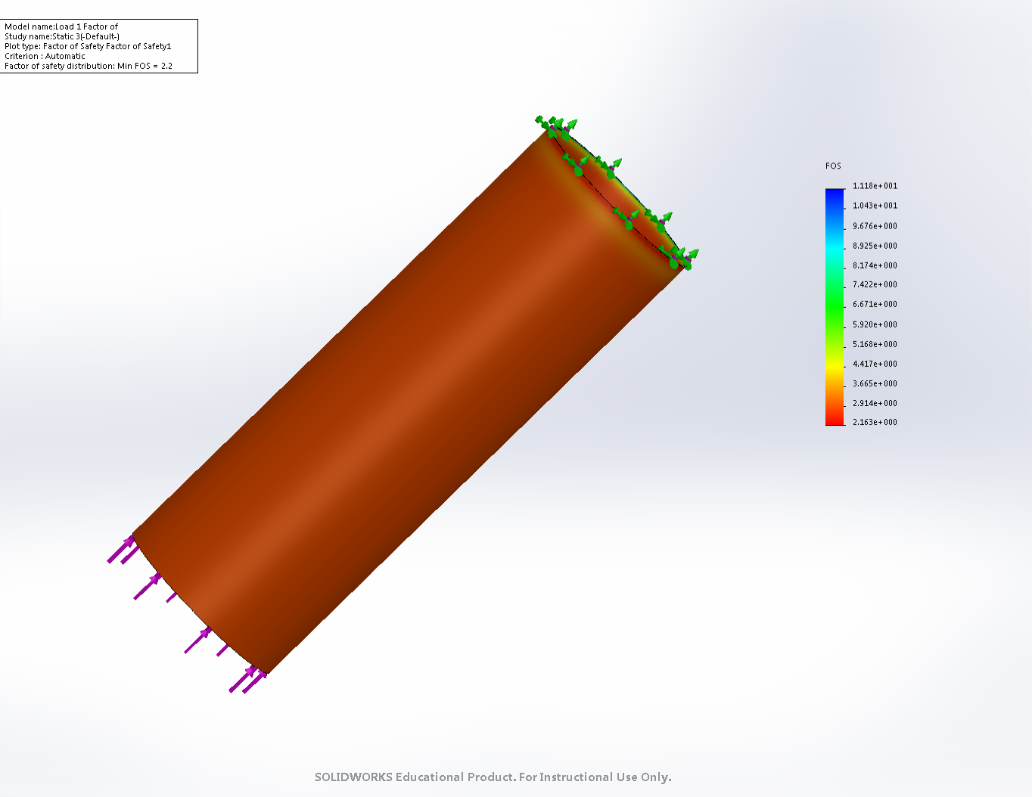

Figure 11: Case 3 Factor of Safety Plot: Incorrect Thickness

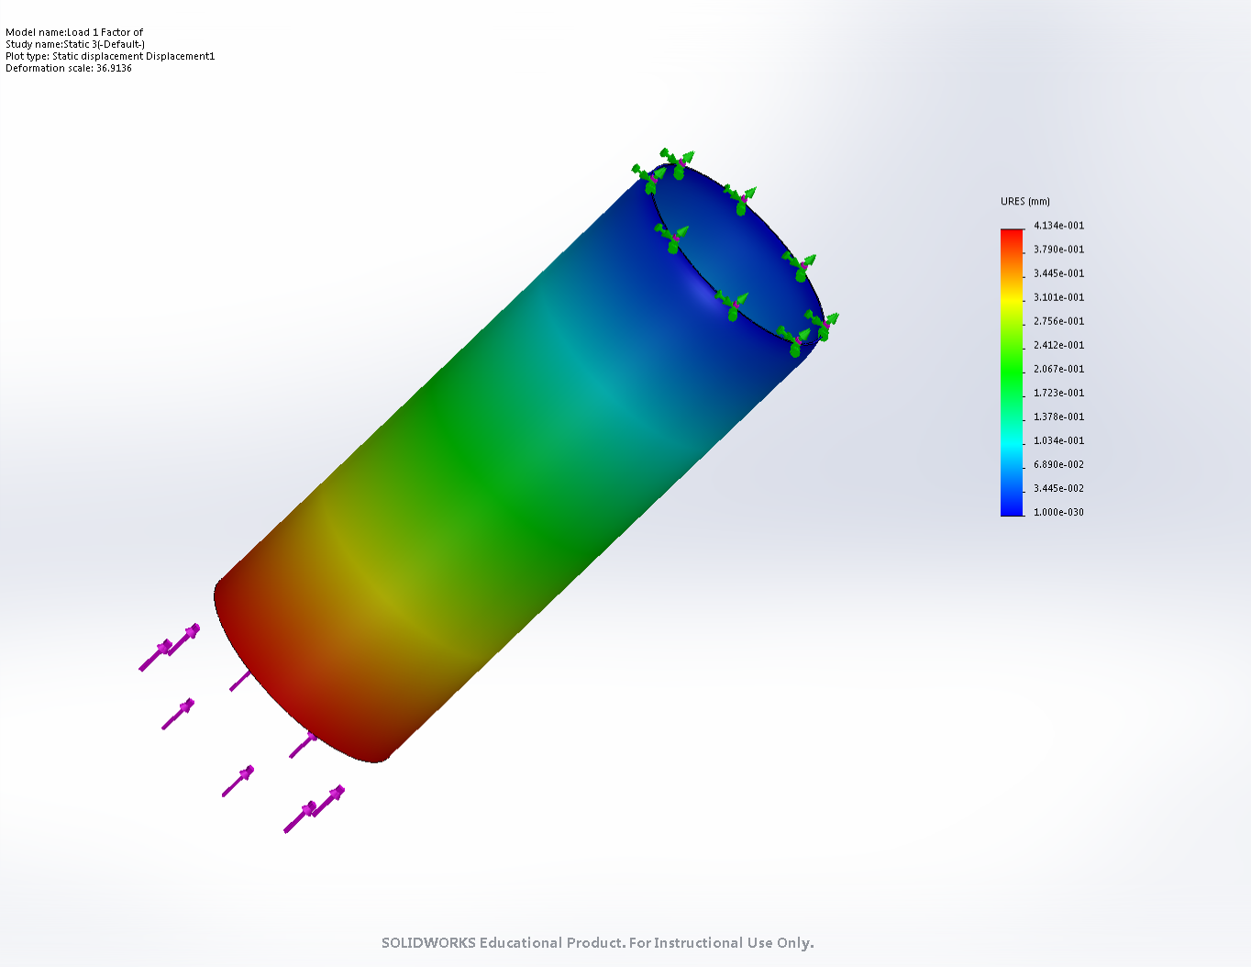

Figure 12: Case 3 Displacement Plot: Incorrect Thickness.